**APPLICATION OF IMAGE PROCESSING TECHNIQUES TO BONE RADIOGRAPH IMAGES FOR OSTEOPOROSIS DIAGNOSIS**

*ANIRUDHA SUNDARESAN, GT ID: 903301401  
KRISHNA KUMAR BALAKRISHNAN, GT ID: 903321701*

**PROGRESS REPORT:**

As projected in our initial proposal, we have collected data and have done an extensive literature review on our topic. So far, we have extracted the statistical and transform based features of the given images. Enhancing the contrast of the images (as shown in the figure below) before feature extraction led to greater accuracy of the SVM classifier used.

C:\Users\Anirudha Sundaresan\AppData\Local\Microsoft\Windows\INetCache\Content.Word\Image_Blind_1.tif 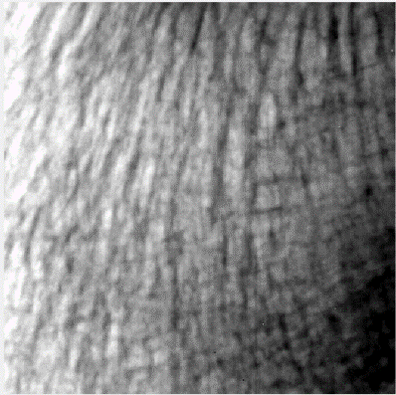

Before contrast enhancement After contrast enhancement

Statistical features used include the mean, standard deviation, entropy and the features associated with the GLCM (Gray-Level Co-occurrence Matrix) - energy, correlation, contrast and homogeneity. In frequency based approach, we have utilized the discrete cosine transform (DCT) coefficients as they provide information about texture specific spectral characteristics. Lower frequencies indicate coarse textures whereas higher frequency represent fine textures.

In wavelet based approach, each image has been decomposed using the Haar wavelets. For extracting the Haar wavelet features we need to have images with dyadic dimensions. Thus, each 400x400 image has been resized to a 256x256 image. Mean of the Haar high frequency wavelet coefficients along the horizontal and vertical direction (HH block) for every level of decomposition gives the texture features, which when fed into the classifier is shown to improve the accuracy when used along with the statistical features. We have used a SVM classifier (with a linear kernel) as the number of samples in the original data is quite low.

**INITIAL RESULTS:**

|  |  |  |  |  |  |  |  |  |
| --- | --- | --- | --- | --- | --- | --- | --- | --- |
| Number of Samples | Features Extracted | TP | FP | TN | FN | SN (Sensitivity) in % | SP (Specificity) in % | Accuracy in % |
| 116  (58 Osteoporotic + 58 Normal) | Only Statistical | 36 | 22 | 36 | 22 | 62.07 | 62.07 | 62.069 |
| Transform Based  (Harr & DCT) | 18 | 13 | 45 | 40 | 31.03 | 77.59 | 54.3103 |
| **Statistical + Transform Based** | **39** | **19** | **39** | **19** | **67.24** | **67.24** | **67.24** |
| 464 partitioned training set  (232 Osteoporotic + 232 Normal) | Only Statistical | 0 | 0 | 58 | 58 | 0 | 100 | 50.00 |
| Transform Based  (Harr & DCT) | 39 | 37 | 21 | 19 | 67.24 | 36.21 | 51.72 |
| Statistical + Transform Based | 13 | 06 | 52 | 17 | 22.41 | 89.66 | 56.03 |

Table 1: Results obtained using Support Vector Machine (Linear SVM) classifier. Best results for *Statistical + Transform Based* features.

Statistical features are highly specific to the intensity value of the pixels of the image. Extracting only these features may yield low accuracy as shown in the table 1, due to the high similarity between the textures in osteoporotic and control subjects. Frequency based transforms do not provide sufficient information of the image regarding the texture features, hence it must be used along with the statistical parameters for better classification.

**FURTHER WORK:**

We plan to generate more data for training by partitioning existing images into overlapping sets as texture properties will be retained. We plan to extract more features, such as the fractal dimension[2] of the image and also aim to explore the properties of covariance matrices[1], space domain techniques[3] (Local Binary Pattern) and directional wavelet transforms (curvelets) to extract robust texture features in the image. We also plan to utilize neural networks and cross validation classification techniques, along with non-linear kernels for training the extended data to obtain better results.

**REFERENCES**

[1] F. Yger Challenge IEEE-ISBI/TCB: “Application of Covariance matrices and Wavelet Marginals”; *CoRR* 2014*.*

[2] Keni Zheng, Sokratis Makrogiannis, *Lecture Notes in Computer Science,* vol. 10530, pp. 158, 2017, ISSN 0302-9743, ISBN 978-3-319-67433-9.

[3] Y. Hu, Z. Long, G. AlRegib, “Scale Selective Extended Local Binary Pattern for Texture Classification”; *IEEE International Conference on Acoustics, Speech and Signal Processing (ICASSP2017),* New Orleans, March 2017.

[4] Hany M Harb, Abeer S Desuky, Asmaa Mohammed and Rachid Jennane. “Histogram of Oriented Gradients and Texture Features for Bone Texture Characterization”; *International Journal of Computer Applications 165(3):* 23-28, May 2017.

[5] Marouane Ben Haj Ayech, Hamid Amiri, “Texture Description Using Statistical Feature Extraction”; *2nd International Conference on Advanced Technologies for Signal and Image Processing -* ATSIP'2016 March 21-24, 2016.

[6] Ahmadv, A., and M. R. Daliri. "A review on texture analysis methods in biomedical image processing." *OMICS J Radiol* (2016).